**A1776 Q­uick Start Guide**

1 Product Declaration

The phone support Phone/Dialer、Contacts、Camera、Messages、Clock、Gallery、Calendar、FM radio、Music、Browser、Video、Calculator、Settings、Notes、Audio Recorder、File Manager、Email、Torch、[Internet Connection](E:/mysoftware/youdao/Dict/8.9.3.0/resultui/html/index.html" \l "/javascript:;)、Bluetooth、GPS、VoLTE、Google Assistant、YouTube、Google Maps、Google Search、Facebook、Twitter and so on.

Here are the product specifications:

|  |  |
| --- | --- |
| CPU | Qualcomm MSM8909 Quad core@1.1G Hz |
| OS Support | Kai OS |
| Screen | Internal 3.2”, external 1.44” |
| Dimension | 117\*61\*20.9mm |
| Weight | 150g |
| Memory | 512MB |
| Storage | 4GB eMMC |
| Camera | Front Camera: 2M FF ,Rear Camera:  5M AF |
| Interface | micro USB/ Single Nano SIM/3.5mm HS jack/SD card/Dual MIC |
| Network | FDD\_LTE (2, 4,5,12,13,25,26,71);  TDD\_LTE(41); |
| Connections | Bluetooth 4.2 / [Internet Connection](E:/mysoftware/youdao/Dict/8.9.3.0/resultui/html/index.html" \l "/javascript:;) 11 b,g,n/ GPS, A-GPS, FM |
| Battery | 2000mAh (Li-ion) |
| Charger | 5V/700mA |

**2 Product Overview**

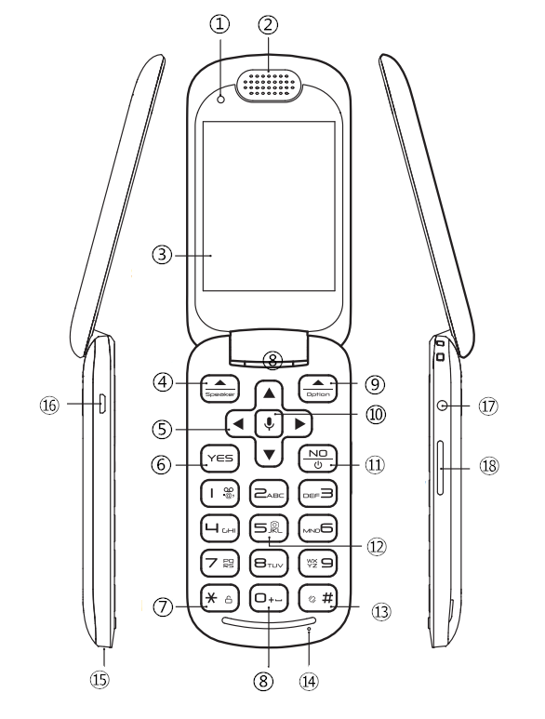 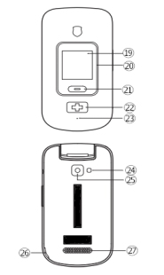

|  |  |  |  |
| --- | --- | --- | --- |
| 1 | Front-camera | 2 | Receiver |
| 3 | Main Screen | 4 | LSK Key/Speaker |
| 5 | Navi Key | 6 | Call Key |
| 7 | Lock/Unlock | 8 | Browser |
| 9 | RSK Key/Option | 10 | GoogleVoice/Enter Key |
| 11 | End Call/Power Key | 12 | Camera |
| 13 | Vibration/Sound | 14 | Microphone |
| 15 | DockChargingConnector | 16 | USB Connector |
| 17 | Earphone | 18 | Volume Key |
| 19 | Front Screen | 20 | LED Indicator |
| 21 | Flip Key | 22 | SOS Key |
| 23 | Microphone | 24 | Flashlight |
| 25 | Rear Camera | 26 | Remove BatteryDoor From Here |
| 27 | Speaker | 28 |  |

# **3 [Basic](G:/mysoftware/Dict/7.1.0.0421/resultui/dict/?keyword=basic) [Operation](G:/mysoftware/Dict/7.1.0.0421/resultui/dict/?keyword=operation)**

3.1 Installation SIM and SD card

Before turning on the phone the SIM card should be installed. Please pay attention not to damage SIM card when inserting into slot. SIM cards should be kept out of child reach.

Phone is equipped with nanoSIM slot. If you have different size of SIM card without possibility to change the size yourself, please contact your operator who should provide you with correct SIM card.

In order to insert SIM card please follow these steps:

* When phone is turned off, open the battery cover. Start by lifting the bottom corner.
* Take out battery.
* Slide down metal cover of SIM card slot.
* Place nanoSIM in the slot according to drawing. Make sure that notch is facing upwards.
* Close metal cover of SIM card slot and slide it up to secure SIM card in place.
* Memory card microSD can be inserted similarly to SIM card. Memory card slot is placed towards the back of the phone.

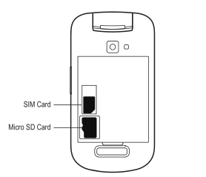

3.1 SIM/SD Card

*Be careful while using memory cards especially while inserting and removing the card. Some memory cards must be formatted on a computer before the first use. Regularly make backup copies of data stored on cards used in other devices, if you use SD Cards! Misuse or other factors might damage the card or make the card lose its content.*

**3.2 Turning the phone on/off**

**1.To turn On the phone**

Press and hold the the Red button for a few seconds.You will see boot animation .

 

3.2 Boot Animation

On the first launch of the phone with selected SIM card (or after restoring factory settings) you will be asked several configuration questions.

First please choose language that you would like to use on the phone. At this step you can also turn on text-to-speech settings.

In the second step you can choose to login to one of available networks.

In the third step you can set data and time.

Next you will see Anti-Theft tips and then you will be asked KaiOS License Terms and Privacy Policy .If you agree, please check “Accept”. And acceptance of KaiOS License Terms and Privacy Policy is required to use this devices.

Next you will see some information about KaiOS,if you have interest,you can check “more” to know about more information.If not,please check”next”.

Finally you will learn keytip and you can use the phone now.

**2.To turn Off the phone**

Press and hold the the Red button  , select Power Off.

Press GoogleVoice/Enter Key . The phone will be off in a few seconds.

**3.Keyboard lock and unlock**

In order to lock keyboard in the standby mode press and hold “\*“ key 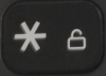 or press the red key to select “Lock”.

In order to unlock keyboard in the standby modePress,You should wake up the phone press the red  key before press and hold “\*“ key  .You do not have to unlock the keyboard to answer a call.You can also confiure your phone to automatically lock .Press GoogleVoice/Enter Key,enter menu →Settings →Personlization →Display →Auto Keypad Lock.

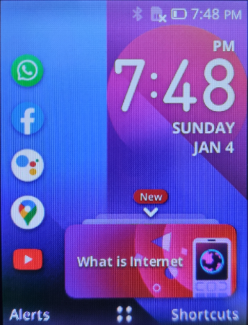 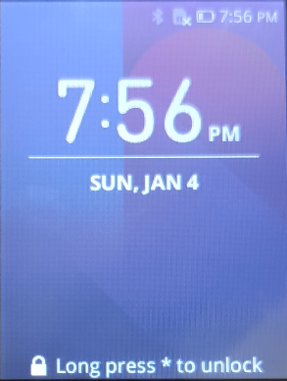

3.3 Unlock/Lock

**3.3 Charging**

Never use a charger or battery that is damaged or not manufactured by the Manufacturer. Accessories of different type or modifications might damage the phone and might give basis for violation of regulations pertaining to radio devices, and might void the warranty.

When the battery is discharged, there will be an icon of the empty battery displayed on the screen. To charge the battery, plug the charger to the power outlet and to the phone. The battery icon will show little bolt symbol as long as the battery is being charged.After certain time, batteries wear out; therefore, their performance time will get shorter and shorter over time.

In order to charge phone:

* Plug charger into power outlet.
* Plug charger cable into charging port at the bottom of the phone. On battery icon you will be able to see little bolt symbol.
* When phone will be fully charged unplug charger from power outlet and cable from phone.

**Attention:**

* Before starting charging make sure the battery is properly installed.
* During charging do not take out battery.
* If battery voltage is too low, phone will turn off automatically.
* If the battery it completely flat, you will have to charge it for several minutes before you are able to turn on the phone.

**3.4 Nav Key**

1.Up key :Short press will access to information page;Long press will turn on/off the flashlight.

2.Down key :Quick access to phone book page.

3.Left key :Quick access to assistant page.

4.Right key :Quick access to camera page.

**4 Basic functions**

**4.1 Calling**

**4.1.1 Emergency Call**

1.Press and hold the SOS key  to start the emergency call when the flip phone is closed.And hold for 3 seconds the phone will vibrate and give voice prompt “Please open flip phone”.

2.Please open the flip phone,and you can see the page of emergency call connecting.

3.To hang up press the Red button .And then you can see the Emergency call back mode information in the alerts at standby mode.

**4.1.2 Calling a number**

1.Input the number you want to call at main screen in standby mode like this.

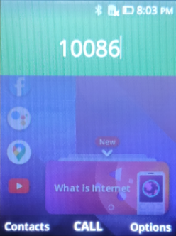

4.1 Input a Number

2.Press Green button  or press GoogleVoice/Enter Key to start the call.

3.To hang up press Red button .

While entering foreign numbers, always enter “+”(instead of “00”) prior to entering the actual number.

**4.1.3** **Choosing number from phonebook or last calls**

In the standby mode please press DOWN key  to enter phonebook. Using up/down keys choose desired contact. Press Green key  to call the number.In the standby mode please press Green key  to enter call log.

**4.1.4 Receiving a call or rejecting a call**

In order to pick up incoming call press Green key .Also you can configure your phone “Flip open to answer”. Press GoogleVoice/Enter Key ,enter menu →Settings →Personlization →Answer Mode→Flip open to answer.

In order to reject incoming call please press Red key .

**4.2 [Internet Connection](E:/mysoftware/youdao/Dict/8.9.3.0/resultui/html/index.html" \l "/javascript:;)**

1.Press GoogleVoice/Enter Key →Settings → Network & Connectivity → [Internet Connection](E:/mysoftware/youdao/Dict/8.9.3.0/resultui/html/index.html" \l "/javascript:;).

2.Enable [internet connection](E:/mysoftware/youdao/Dict/8.9.3.0/resultui/html/index.html" \l "/javascript:;) by pressing the up key or down key. Then select the Available Networks,The phone scans for networks in range.Select Rescan,the phone will scan for networks in range again.

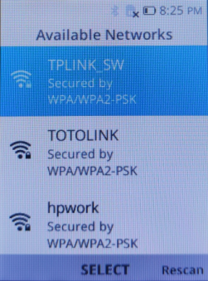

4.2 Available Networks

3.Choose the network you want to connect to.

4.Type a password (if connecting to a secure network) and  connect to  the selected network.

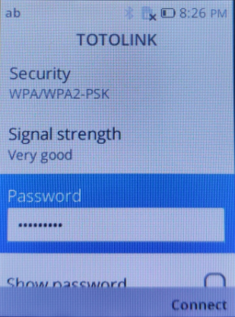

4.3 Type a password

**NOTE:**

*To connect to a secured network, you must provide the security key. If you do not have the security key, contact the person who manage your network or the router manufacturer.*

*The range and quality of the network signal is affected by the distance between the tablet and the wireless router, the number of connected devices,infructure,and objects objects through which the signal is transmitted.*

**4.3 Main menu**

In order to enter main menu, press GoogleVoice/Enter Key  when in Standby mode. Use UP/DOWN/LEFT/RIGHT navigation keys to move around the menu. To confirm choice please press GoogleVoice/Enter Key . To go back please press Red button .

## **4.4** SMS and MMS messages

### **4.4.1** Writing and sending texts

1.Enter MENU and choose Messages C:/Users/Administrator/AppData/Local/Temp/kaimatting_20190916162854/output_20190916162906..pngoutput_20190916162906. -> New to open editor.

2.Enter message and choose to who do you want to send the message by choosing contact from list or typing number directly.

**Changing input method.** In order to change input method(numbers, small/capital letter/Predictive mode) keep pressing “#” key.

By holding “#” key you can change input language. First you need to select what languages you would like to use. You can do it in the main setting of the phone.

### 4.4.2 Reading and replying to texts.

When unread message icon will display on the screen or you want to check previous messages in MENU choose Messages and navigate to desired thread. You will be able to read the whole message history with chosen contact and well as perform additional actions.

## **4.5 Camera**

Enter Menu and choose CameraC:/Users/Administrator/AppData/Local/Temp/kaimatting_20190916162931/output_20190916162940..pngoutput_20190916162940. or press Right key to quick enter Camera. You should press GoogleVoice/Enter key to take a picture in the default settings. In order to zoom in/zoom out use UP/DOWN keys.

Immediately after you take the picture you can jump to gallery where you can edit the picture, share it with friends or set as wallpaper.

By pressing “Options” in the camera mode you can switch between main camera and front camera or change mode to video recording.

## **4.6 Web browser**

To use internet open the browser appE:\QC32A\说明书\mag\ET]RXHQ7M(P]GP9CS6QWYMQ.pngET]RXHQ7M(P]GP9CS6QWYMQ.

By default you can navigate page with clickable arrow pointer.

In order to switch to smooth scrolling mode press “2” and then use “1” or “3” keys to zoom in/zoom out.

By pressing options you can change volume, refresh page or manage bookmarks.

## **4.7 Calendar**

After opening the calendar appC:/Users/Administrator/AppData/Local/Temp/kaimatting_20190916163358/output_20190916163403..pngoutput_20190916163403. you will see today’s date. Press GoogleVoice/Enter Key again to display full calendar. Using navigation keys you can move between date and times. When you choose desired time and date press “Add” to add event to calendar.

By pressing “Option” you can switch between Week/Month/Day view.

In calendar settings you can set up synchronization with i.e. Google Calendar and choose how often synchronization should occur.

## **4.8 Music**

Music app allows to play music stored in the phone memory or on the memory card. This application can also run in the background allowing you to listen to music and use other apps at the same time.

## **4.9 FM Radio**

In order to use FM Radio you have to plug in headset included in the set.

After Radio appC:/Users/Administrator/AppData/Local/Temp/kaimatting_20190916164310/output_20190916164321..pngoutput_20190916164321. is launched for the first time phone will ask you to search for available stations.

This application can also run in the background allowing you to listen to the radio and use other apps at the same time.

## **4.10 Change language**

If you accidently change language go to standby mode and following steps:

1. Press GoogleVoice/Enter Key →Settings → Personlization→ Language.
2. Choose language from list.

## **4.11 Memmory**

In the Memory tab in the Main Settings you will find USB memory settings. If you want to access your phone memory from computer via USB cable you have to switch USB Memory to ON.

**5 Safety instruction**

1.Keep your phone and its accessories out of the reach of pets.

2.Do not allow children to use your phone. If children use the device, make sure that they use the phone properly.

3.Do not try to dry your phone in a microwave oven. If you do, sparks can occur and cause an explosion or fire.

4.Do not use or store your phone in dusty or dirty areas.

5.Do not attempt to disassemble your phone.

6.Do not drop or cause severe impact to your phone.

7.Do not use chemical products, cleaning solvents or detergents to clean your phone.

8.If your phone does not work properly, contact your dealer immediately.

9.Never leave the charger connected longer than 2-3 days.

10.Never keep the phone in excessively hot places. High temperatures might negatively impact both the battery and the phone.

11.Never use a battery that is clearly damaged. Doing so might cause a short circuit, and might damage the phone.

12.Don't throw away the battery, it is dangerous to explode.

13.Never throw the phone nor accessories to municipal solid waste!!!The product should be utilized in authorized places.As the product contains hazardous components, improper storage and use of such equipment might lead to serious consequences harmful for both people and natural environment. To avoid such consequences, proper handling of waste electrical and electronic equipment is essential.